# open filer

Introduction

**openfiler** is an [operating system](https://en.wikipedia.org/wiki/Operating_system) that provides file-based [network-attached storage](https://en.wikipedia.org/wiki/Network-attached_storage) and block-based [storage area network](https://en.wikipedia.org/wiki/Storage_area_network). It was created by Xinit Systems, and is based on the [CentOS](https://en.wikipedia.org/wiki/CentOS) [Linux distribution](https://en.wikipedia.org/wiki/Linux_distribution). It is [free software](https://en.wikipedia.org/wiki/Free_software) licensed under the [GNU GPLv2](https://en.wikipedia.org/wiki/GNU_GPLv2).

The Openfiler codebase was started at Xinit Systems in 2001. The company created a project and donated the codebase to it in October 2003.The first public release of Openfiler was made in May 2004. The latest release was published in 2011.

Project summary

| website | www.openfiler.com |
| --- | --- |
| Organization | Xinit Systems |
| license | GNU GPLv2 |
| proprietary | Openfiler converts an industry standard x86_64 architecture system into a full-fledged NAS/SAN appliance or IP storage gateway and provides storage administrators with a powerful tool to cope with burgeoning storage needs. |
| Source path | Openfiler consolidates several open source technologies on the Linux kernel base to deliver a comprehensive storage management solution that meets the needs of enterprise applications, users and administrators. |
| Brief Description | **Openfiler provides a simple way to deploy and manage networked storage.**Installing Openfiler results in a powerful networked storage solution that exports your data via a full suite of industry standard storage networking protocols. Openfiler lowers deployment and maintenance costs for networked storage without compromising functionality or performance. |

Project details

Key features:

Openfiler key features such as iSCSI target for virtualization, Fibre Channel target support, block level replication and High Availabilty that are the mainstay of any business critical storage environment.

Architecture: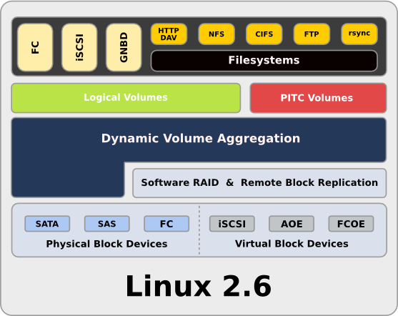

Current usage:

Openfiler includes support for volume-based partitioning, iSCSI(target and initiator), scheduled snapshots, resource quota, and a single unified interface for share management which makes allocating shares for various network file-system protocols a breeze.

Technical details:

Technical features in a storage solution can compensate for a lack of good administrative capabilities. Openfiler meets this challenge head-on with its powerful and intuitive web-based graphical user interface (GUI). All facets of the trove of storage networking capabilities in Openfiler are controlled via this management interface. Management capabilities are grouped into separate sub-interfaces in accordance with their functional domain; networking, physical volumes, user and group authentication/authorization, system configuration and status information are each given a scope.

Other information:

**Openfiler provides a simple way to deploy and manage networked storage.** Installing Openfiler results in a powerful networked storage solution that exports your data via a full suite of industry standard storage networking protocols. Openfiler lowers deployment and maintenance costs for networked storage without compromising functionality or performance.

END